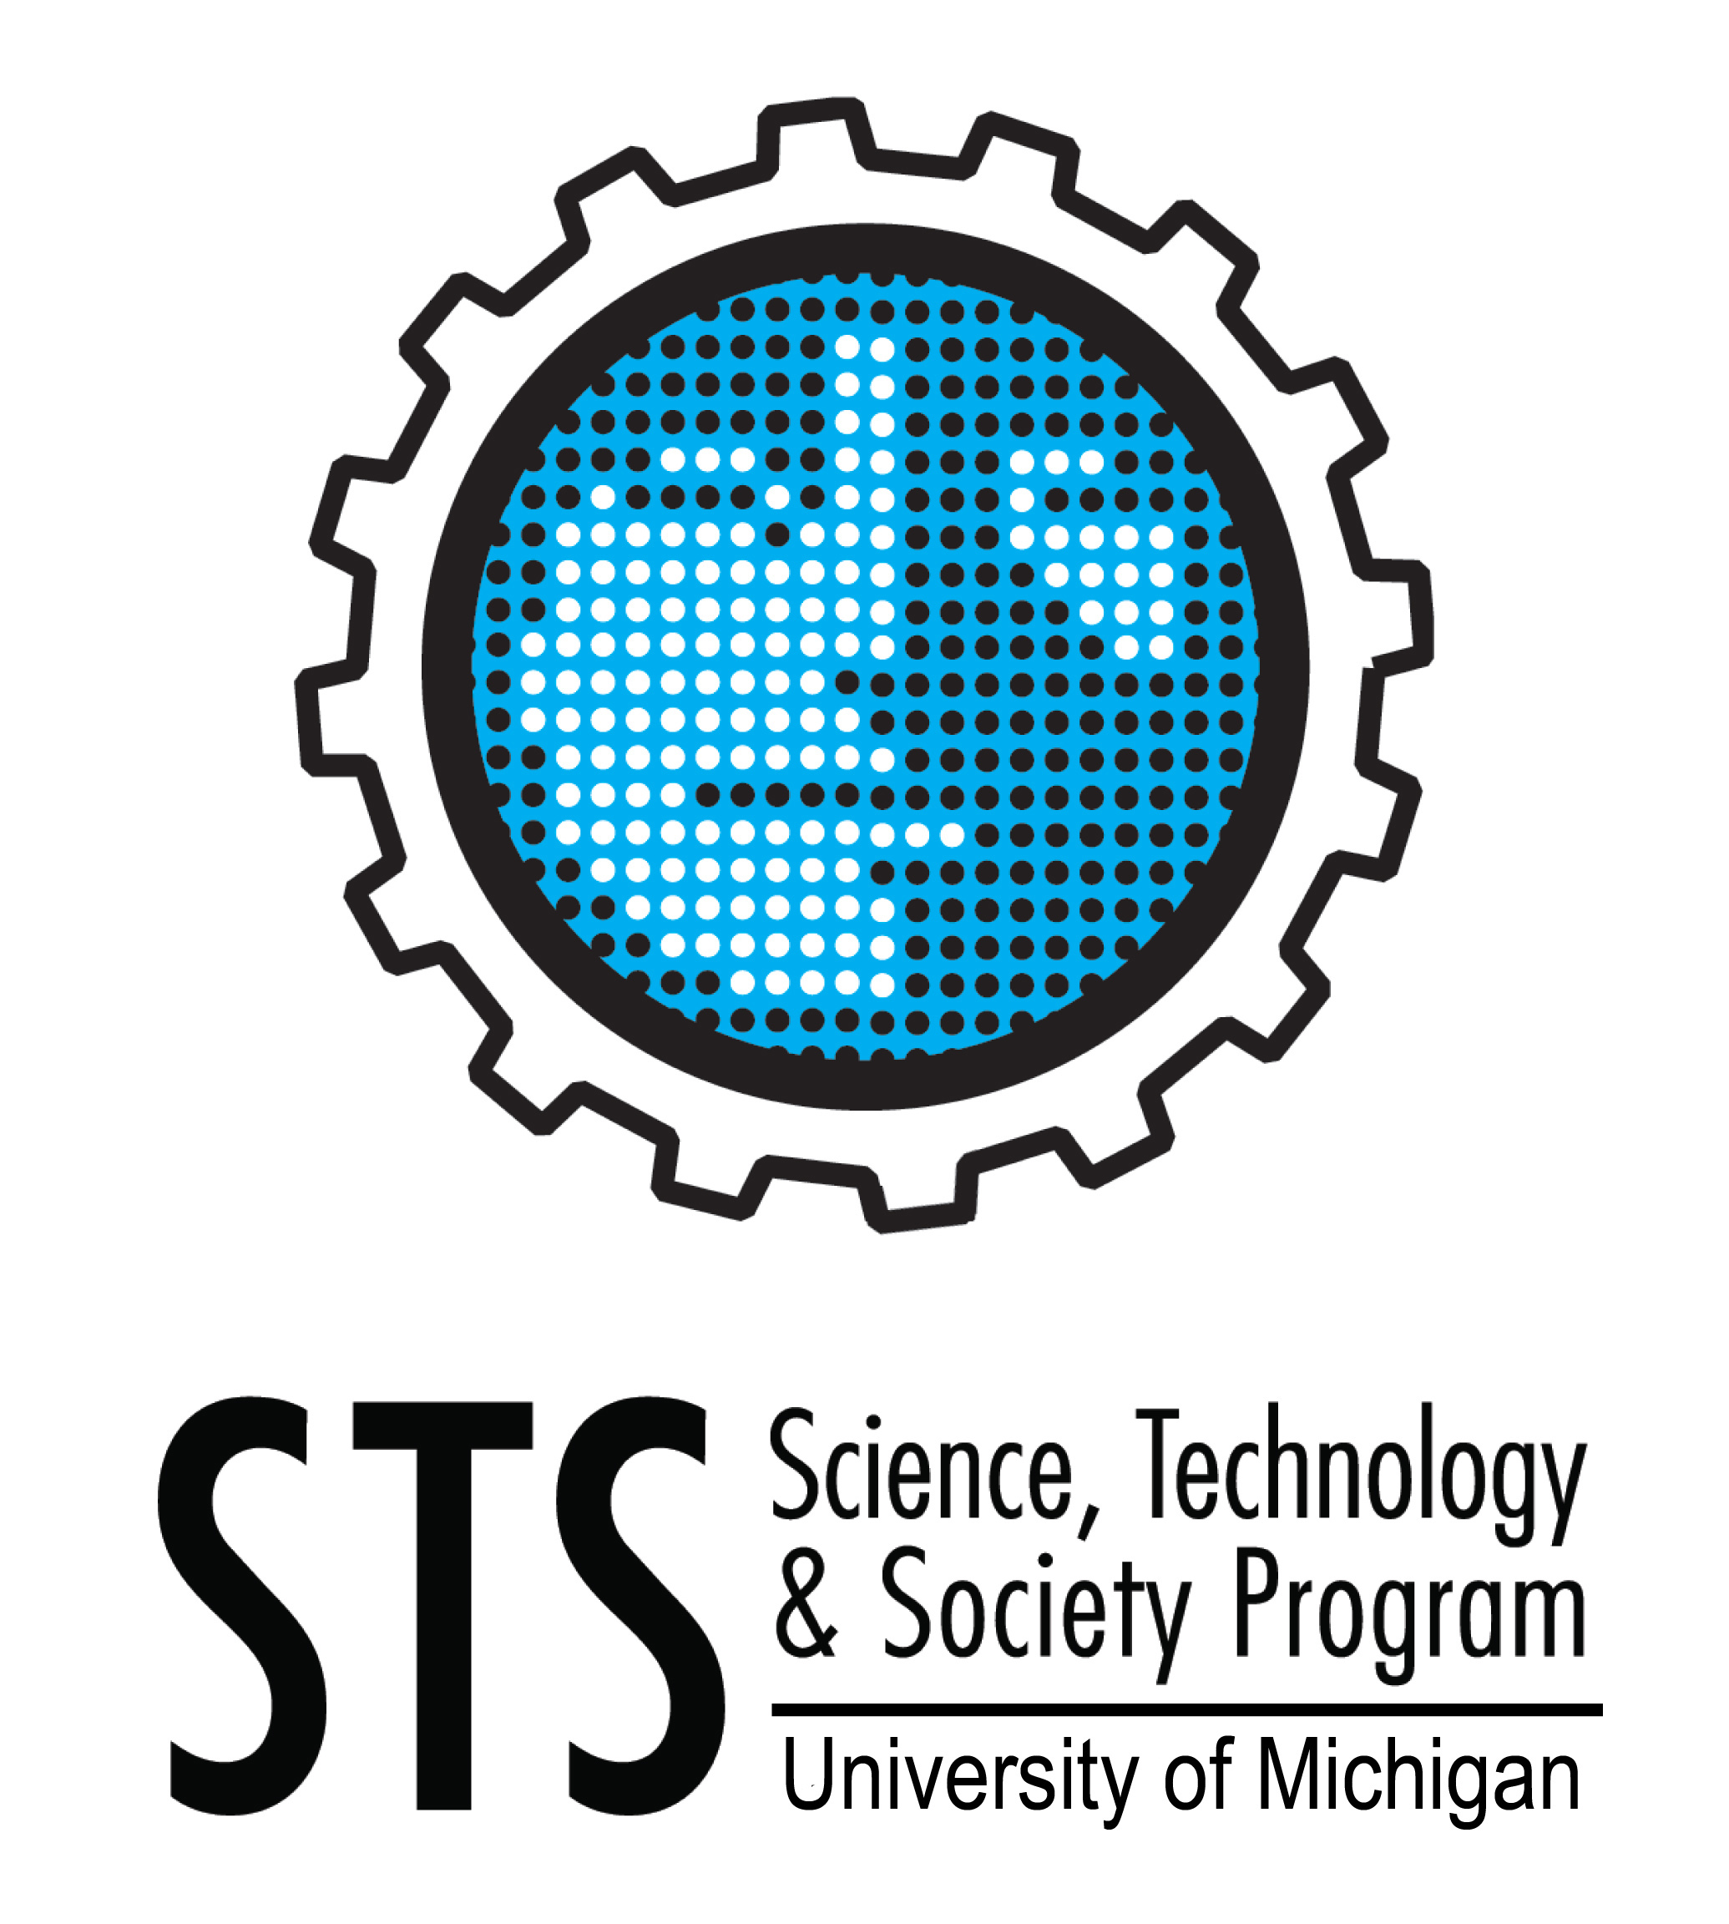
Science, Technology, Medicine and Society Speaker Series
Fall 2018

Monday, 17 September  “Collecting Bodies, Bodily Collectives: Trace Identities in British India, 1918-47”  Projit Bihari Mukharji  University of Pennsylvania  Co-sponsored by Center for South Asian Studies  Monday, 8 October  “Alternative Facts and States of Fear: Reality in the Age of Climate Fictions”  Joanna Radin  Yale University  Monday, 22 October  “Unbalancing the Senses and Sciences of Moving Fascia: Practicing Research”  Joseph Dumit  University of California, Davis  Cosponsored by the Department of Anthropology  Monday, 5 November  “Community as Ecofact or Artifact: Myths Of Meritocracy and ‘Fun Work’ in North-South American Field Science Collaborations”  Mary Leighton  UM-Department of Anthropology  Monday, 3 December  “The Sentimental Body: Medical Humanitarianism and the Late Colonial Public in Indonesia”  Kevin Ko  UM-History |  | Other Events of Interest  Friday, 14 September  “The Promise of Making: Desiring Alternatives and Hacking Entrepreneurial Living in China”  Silvia Lindtner, U-M School of Information  ** 1:30 pm, RO220 Ross School of Business  Sponsored by the Interdisciplinary Committee on Organizational Studies  Friday, 21 September  “Crowded Places: Slavery, Science, and the Roots of Fresh Air in the Atlantic World”  Jim Downs, Connecticut College  **2:00pm, 1014 Tisch Hall  Friday, 26 October  “Technosemiotics Workshop”  Matthew Hull, U-M Department of Anthropology  Miyako Inoue, Anthropology, Stanford University  Brian Larkin, Anthropology, Columbia University  **Time and Place TBD.  Sponsored by the Department of Anthropology  Wednesday, 5 December  New Book Panel: Robo sapiens japanicus: Gender, Family, and the Japanese Nation by Jennifer Robertson  Jennifer Robertson, U-M Anthropology  Joy Rohde, U-M Public Policy  Alexandra Minna Stern, U-M American Culture, History, Women’s Studies, Obstetrics & Gynecology  ** 3:00-4:30pm, 2339 Lane Hall  Sponsored by IRWG, Women’s Studies Department  Thursday, 6 December  “Automating Inequality: How High-Tech Tools Profile, Police, and Punish the Poor”  Virginia Eubanks, SUNY-Albany  ** 4:00pm, Annenberg Auditorium, Weill Hall  Sponsored by the Ford School of Public Policy and the program in Science, Technology and Public Policy
STS Events run 4:00-5:30pm in 1014 Tisch Hall, 435 South State Street, unless otherwise noted.
Free and open to the public.
For more information: Program in Science, Technology & Society
734-763-2066 umstscontact@umich.edu www.lsa.umich.edu/sts

The Science, Technology, Medicine and Society (STeMS) Speaker Series is made possible by contributions from the Department of History, the LS&A Dean’s Office, and the School of Information.

