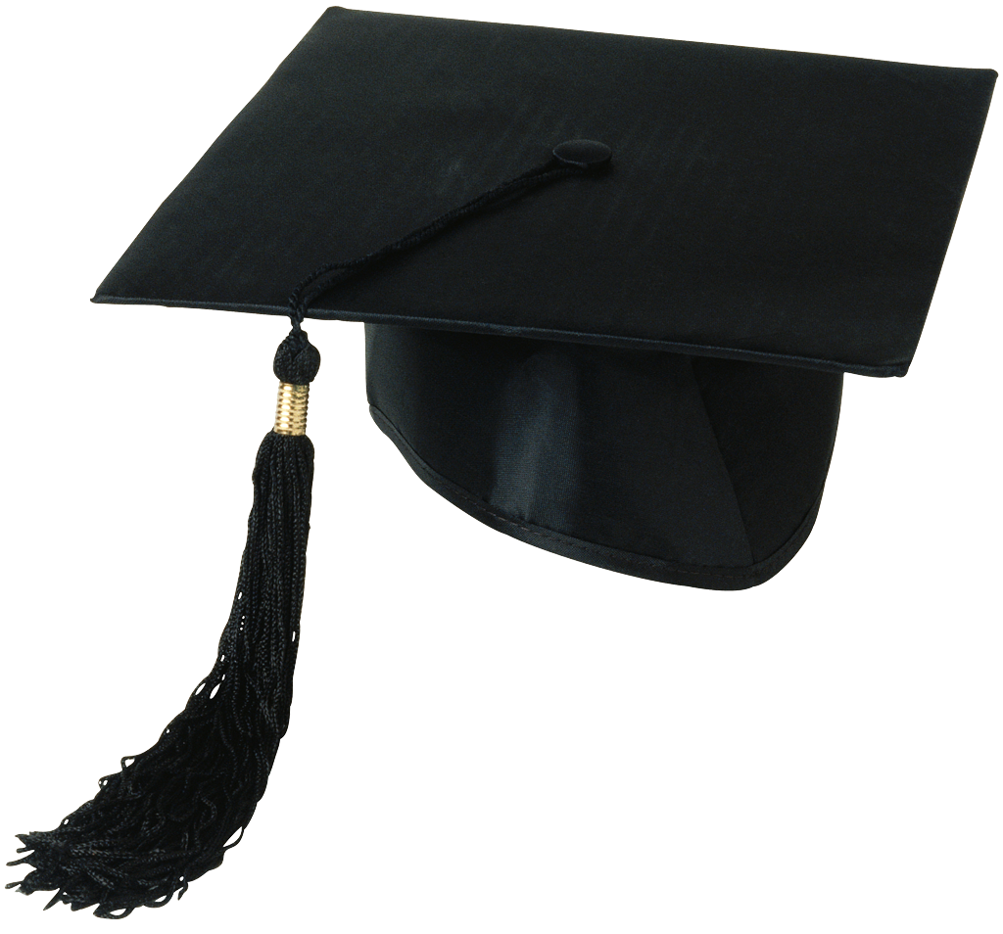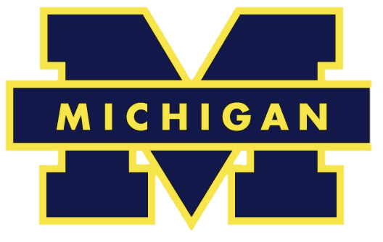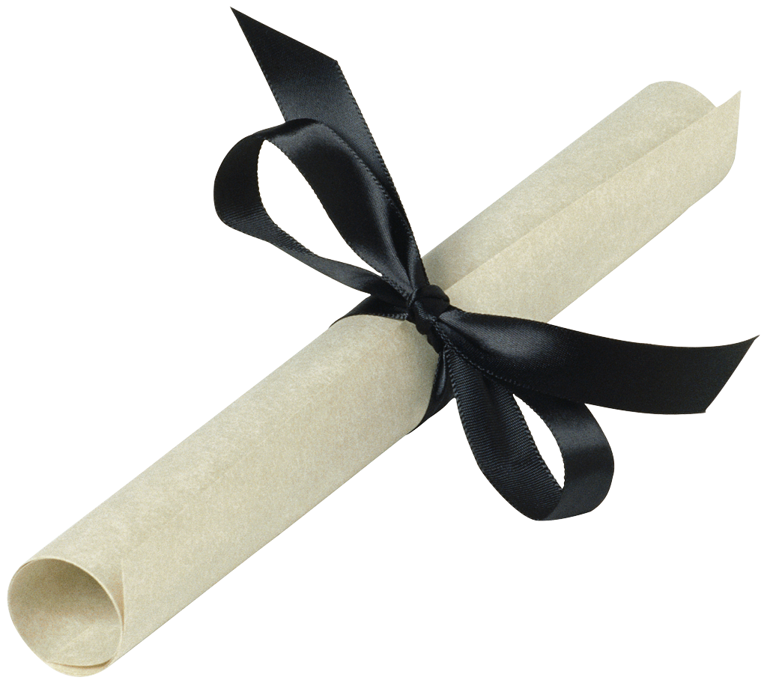

Ann Arbor Shopping

Clothing and Michigan Merchandise:

[Briarwood Mall](http://www.simon.com/mall/briarwood-mall) (take AATA 6 from downtown)

[The M Den](http://www.mden.com/) (15 minute walk from Diag)

[MooseJaw](http://www.moosejaw.com/moosejaw/shop/content_ann-arbor-shop____) (25 minute walk from Diag)

[Sam’s Clothing](http://www.samsbasicclothes.com/) (25 minute walk from the Diag)

Food and Grocery Shopping:

[Meijer](http://www.meijer.com/) (take [AATA 6](http://www.theride.org/SchedulesMapsTools/MapRoutePDFs) from downtown)

[Kroger](https://www.kroger.com/) (take [AATA 2A](http://www.theride.org/SchedulesMapsTools/MapRoutePDFs), 2B, or 2C from downtown)

[Whole Foods](http://www.wholefoodsmarket.com/stores/annarbor) (take [AATA 4](http://www.theride.org/SchedulesMapsTools/MapRoutePDFs) from downtown)

[Trader Joe’s](http://www.traderjoes.com/) (take [AATA 4](http://www.theride.org/SchedulesMapsTools/MapRoutePDFs) from downtown)

*Food on the Go! $-$$*

[*Pancheros*](http://pancheros.com/)*,* [*No Thai*](http://nothai.com/)*,* [*Buffalo Wild Wings*](http://www.buffalowildwings.com/?gclid=CNHelraDrcICFUT3wgodkyQAhw)*,* [*Pizza House*](http://www.pizzahouse.com/)*,* [*Good Time Charley’s*](http://www.good-time-charleys.com/)

Hotels for the Perfect Stay…

[The Campus Inn](http://www.campusinn.com/) $$$$

[Bell Tower Hotel](http://www.belltowerhotel.com/) $$$$

[The Residence Inn](http://www.marriott.com/hotels/travel/arrmi-residence-inn-ann-arbor/) $$$

[The Fairfield Inn](http://www.marriott.com/hotels/travel/arbfi-fairfield-inn-ann-arbor/) $$$

[The Lamp Post Inn](http://www.lamppostinn.com/) $$$

[Sheraton](http://www.sheratonannarbor.com/) $$-$$$

[The Kensington Court Hotel](http://www.kcourtaa.com/) $$-$$$

[The Holiday Inn](http://www.ihg.com/holidayinn/hotels/us/en/ann-arbor/arbnc/hoteldetail/) $$

[The Red Roof Inn](https://www.redroof.com/property/Ann-Arbor/MI/48105/Hotels-close-to-University-of-Michigan-U-of-M-Ann-Arbor-I-94-SR-23/RRI045/) $$

Restaurants

### Ann Arbor Sights

The Famous Cube

The Rock

The Big House

The UMMA

Kelsey Museum

The President’s House

The Law Library

The Graduate School Library

The Diag

Downtown Ann Arbor

Kerrytown

Nichols Arboretum

Matthaei Botanical Gardens

Nickel’s Arcade

Crisler Arena

Wave Field (North Campus)

Ann Arbor Hands-On Museum

Lurie Tower

UM Museum of Art

# The most comprehensive list of all things **Ann Arbor**… spend graduation weekend in the best restaurants, hotels, and sights that this college town has to offer!

$$$: [Melting Pot](http://www.meltingpot.com/annarbor-mi/specials), [Pacific Rim](http://pacificrimbykana.com/), [Vinology](http://www.vinologya2.com/), [Chop House](http://thechophouseannarbor.com/), [Gratzi](http://gratzirestaurant.com/), [Melange](http://melangebistro.com/), [The Earle](http://theearle.com/), [The Black Pearl](http://www.blackpearlonmain.com/), [Real Seafood Company](http://realseafoodcoannarbor.com/), [The Gandy Dancer](http://www.muer.com/gandy-dancer/), [Aventura](http://aventuraannarbor.com/#about), [Jolly Pumpkin](http://www.jollypumpkin.com/annarbor/Default.htm)

$$- $$$: [Slurping Turtle](http://slurpingturtle.com/annarbor/), [Tomukun BBQ](http://bbq.tomukun.com/), [Savas](http://www.savasrestaurant.com/), [Zingerman’s Roadhouse](http://www.zingermansroadhouse.com/)

$$- [Tio’s](http://www.tiosmexicancafe.com/), [Bigalora](http://bigalora.com/ann-arbor/), [Angelo’s](http://www.angelosa2.com/), [The Broken Egg](https://plus.google.com/108618756900938199117/about?gl=us&hl=en), [Zingerman’s Delicatessen](http://www.zingermansdeli.com/), [Tomukun Noodle Bar](http://noodlebar.tomukun.com/), [Suvai Taste of India](http://www.tasteofindiaaa.com/)

Ann Arbor, Michigan

*Brought to you by the University of Michigan Psychology Department*

**The Graduation Issue**