Analytical Lab Equipment

Atomic Absorption Spectrophotometer
Shimadzu AA-6200CE
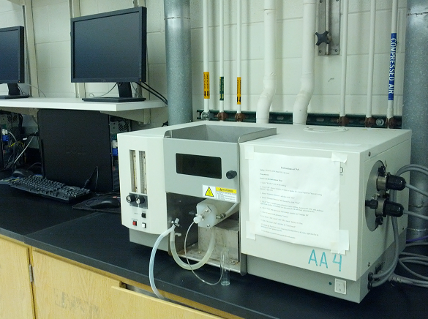
Shimadzu's double beam AA-6200 system uses WindowsTM 95 and AtomicA's software Wizard function to provide easy operation for system control and data processing. It also uses the least linear bench space of any atomic absorption spectrophotometer in the world.
Quantity in the lab: 6
- Optics: double beam
- Monochromator: holographic grating (1,600 lines/mm)
- Wavelength Range: 190-900 nm, automated selection
- Slit: 0.2nm, 0.7nm manual setting
- Lamp Turret: 2 lamps simultaneously lit
- Lamp Mode: emission, non-BGC, BGC-D₂
- Frequency: 100Hz
- Chamber: polypropylene
- Burner: fixed position, titanium 10cm slot burner
- Ambient Temperature Range: 10-35°C
- Humidity Range: 45-80%
- Gas Control: manual setting of flow rate, automatic air/N₂O switching system

UV-VIS Recording Spectrophotometer
Shimadzu UV-2401PC
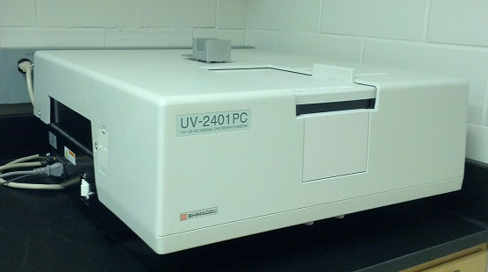
The UV-2401PC is a double beam spectrophotometer which provides UV-Visible spectra and quantitative measurements of an absorbing analyte of interest using Beer’s Law. The low stay light, wide dynamic range, and small beam size make this instrument well-suited for a variety of practical applications.
Quantity in the lab: 1
- Optical System: Double-beam
- Spectral Bandwidth: 0.1, 0.2, 0.5, 1, 2 and 5nm
- Resolution: 0.1nm
- Wavelength Range: 190 to 900nm
- Accuracy: ±0.3nm
- Repeatability: ±0.1nm
- Photometric Readout: Absorbance, %Transmittance, %Reflectance, Energy
- Range: -4.000 to +5.000A; 0 to 999.9%T and %R
- Scan Speeds (approx. at 2.0nm): FAST (1233nm/min.), MEDIUM (641nm/min.), SLOW (467nm/min.), SUPER SLOW (310nm/min.)
- Drift: (after 2 hr. warmup) <0.0004A/hr.
- Lamps: Halogen (50W), deuterium
- Detector: Photomultiplier R-928

FT-IR Spectrometer
Perkin-Elmer Spectrum One

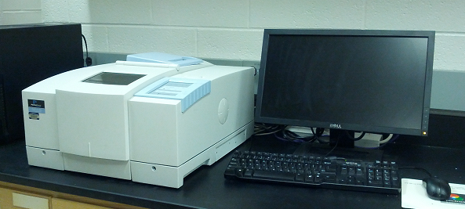
This spectrometer uses a single software platform to incorporate all functions required for infrared analyses, including instrument control, data manipulation and analysis, as well as flexible report utilities. The Michelson interferometer self-compensates for dynamic alignment changes due to tilt and shear. Detectors are electrically temperature-stabilized for fast recovery.
Quantity in the lab: 1
FR-DTGA
- Wavelength Range: 7,800 – 350 cm⁻¹ (with KBr beamsplitter)
- Resolution: 0.5 cm⁻¹ to 64 cm⁻¹
- Wavelength Accuracy: 0.1 cm⁻¹ at 1,600 cm⁻¹
- Available OPD Velocities: 0.1, 0.2, 0.5, 1 and 2 cms⁻¹
LiTaO₃
- Wavelength Range: 7,800 – 350 cm⁻¹ (with KBr beamsplitter), 7,800 – 225 cm⁻¹ (with CsI beamsplitter)
- Resolution: 0.5 cm⁻¹ to 64 cm⁻¹
- Wavelength Accuracy: 0.1 cm⁻¹ at 1,600 cm⁻¹
- Available OPD Velocities: 0.1, 0.2, 0.5, 1 and 2 cms⁻¹

Spectrofluorophotometer
Shimadzu RF-5301PC

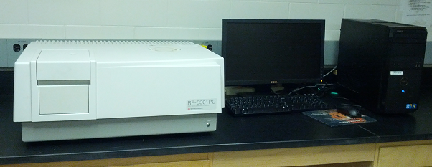
Compared to absorbance methods, fluorescence sensitivity is tens to thousands times better - this means that you can analyze nanogram to picogram samples with great results. When the compound of interest does not exhibit natural fluorescence, functional group-specific probes may be used to label the compound and assist your research. The synchronous scanning mode allows mixtures of fluorochromes to be analyzed. The computer directly controls the instrument for data acquisition and processing. The Windows friendly operating environment allows you to perform measurements, process data, edit and record in one continuous operation with a click of the mouse. Using the Copy Graph function, measurement data or spectra may be easily transferred to word processing or spreadsheet software for preparation of documents or additional calculations.
The essence of fluorescence analysis is sensitivity. The high throughput optical system in the RF-5301PC employs a blazed holographic grating, photomultiplier and digital signal processing to provide the highest level S/N ratio attainable.
Quantity in the lab: 1
- Light Source: 150W Xenon lamp, ozone resolving type lamp housing
- Monochromators: concave, blazed holographic grating, F/2.5, 1,300 grooves/mm
- Wavelength Scale: 220-900nm
- Wavelength Accuracy: ±1.5 nm
- Spectral Bandwidth: 6-step selection of 1.5, 3, 5, 10, 15, and 20nm
- Wavelength Slewing Speed: 20,000nm/min
- Operational Temperature Range: 15-35°C
- Operational Humidity: 40-80%

Gas Chromatography-Mass Spectrometry System
Shimadzu GC-2010 Plus, GCMS-QP2010SE

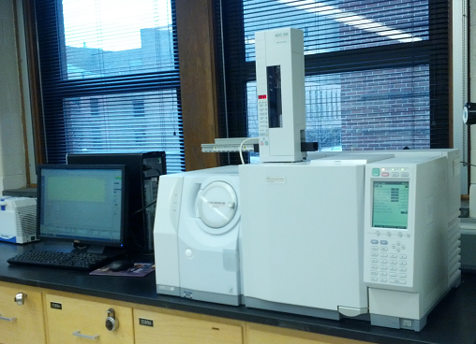
Rapid oven cooling, high performance flow control and backflush technology allow the user to shorten analysis times greatly for significant gains in productivity. The GC-2010 Plus features high-performance GC for fast analysis and is compatible with Hydrogen carrier gas. The GCMS-QP2010SE enables direct sample injection (DI), easy expandability, scans at speeds up to 10,000 u/second, includes three operation modes, and allows column flow up to 4 mL/min for a variety of columns.
Quantity in the lab: 1
- Operational Modes: scan, SIM, scan/SIM
- Mass Spectral Libraries: NIST, Wiley, custom

Gas Chromatography System
Hewlett Packard HP 6890 Plus Series, LabSolutions 61530A

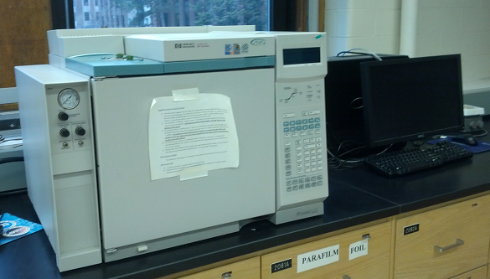
This system has a “built-in” column oven, injection modes for splitting or splitless experiments, an interface for signal outputs for analog recording devices, a programmable keypad, and automated pressure monitoring and regulation using an Electronic Pneumatic Controller. Although standalone, this system may also be computer controlled using Chemstation, ExChrom Elite, or Empower installed on a PC.
Quantity in the lab: 1
- Oven Dimensions: 28 x 31 x 16 cm
- Temperature Range: 4°C above ambient to 450°C
- Resolution: 1°C
- Interfaces: RS232C, HP-IB

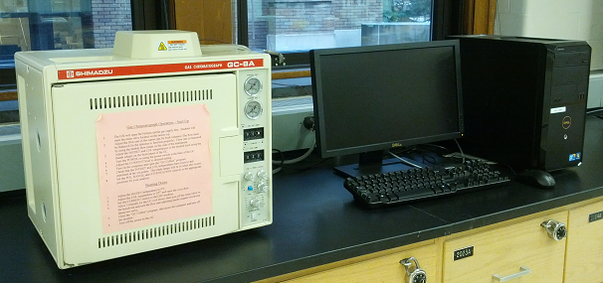
Gas Chromatograph
Shimadzu GC-8AIT

The GC-8A is a rapidly heating and cooling gas chromatograph with exceptional temperature stability and control. The near cubic shape and front-opening oven allow for easy exchange of columns.
Quantity in the lab: 6
- Overheat Prevention Automatic Shut-Off: above 30°C (pre-programmed), above 420°C
- Carrier Gas: 2 pressure regulators, 2 column inlet pressure gauges
- Oven Temperature Range: ambient ~399°C
- Oven Temperature Control Accuracy: ±0.1°C
- Heating Speed: from ambient to 350°C in 13 min.
- Cooling Speed: from 350°C to 100°C in 13 min.
- Column: 6m x 2 (Stainless Steel), 5.4m x 2(glass)
- Injection Port Temperature Range: ambient ~ 400°C (10°C steps)
- Injection Port Temperature Control Accuracy: ±0.1°C
- Detector Maximum Temperature: 400°C
- Thermal Conductivity Detector Bridge Current: constant current system (OFF, 60, 70, 80, 90, 100, 120, 140, 160, 180, 200mA)

HPLC System
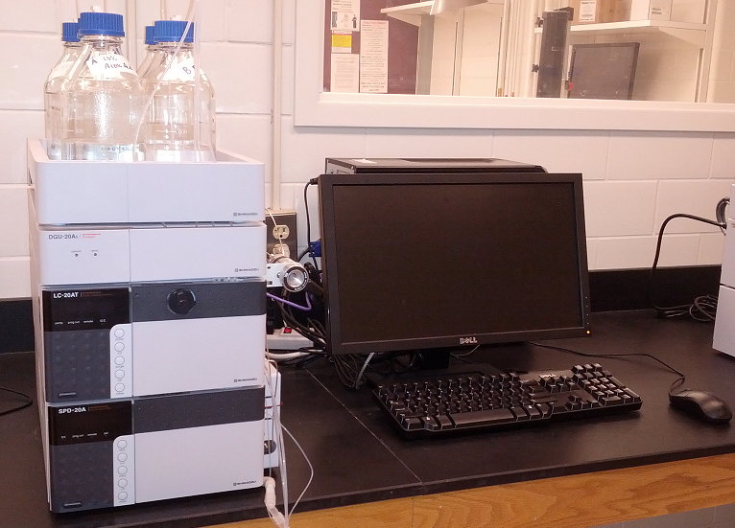
Shimadzu Prominence DGU-20A₅, LC-20AT, SPD-20A

HPLC systems are currently used for faster development of new drugs, for better food safety, and for meeting higher standards in environmental regulations. Many analysis techniques use LCMS, which requires a front-end HPLC system to provide solvent delivery performance in the micro to semi-micro range and injectors with low sample carryover. Prominence features the world's first Web control, fastest sample injection, and highest detection sensitivity performance.
Quantity in the lab: 6

DGU-20A₅
The DGU-20A₅ is an on-line degassing unit that uses fluoroethylene membrane. The internal capacity is only 1/25th of previous models, and waiting time at mobile phase replacement or stabilization can be significantly reduced.
LC-20AT
This serial double-plunger model is designed to be especially easy to operate and maintain, without compromising its superior performance. Innovations to the pump head structure and other aspects provide improved bubble removal. This model allows including a low-pressure gradient unit.
Flow rate range: 0.001 to 10.000 mL/min.
SPD-20A
The SPD-20A is a UV-VIS detector that takes sensitivity to the limit (Noise level 0.5 x 10(-5) AU), and offers wide linearity (2.5AU).
Wavelength range: 190 to 700nm

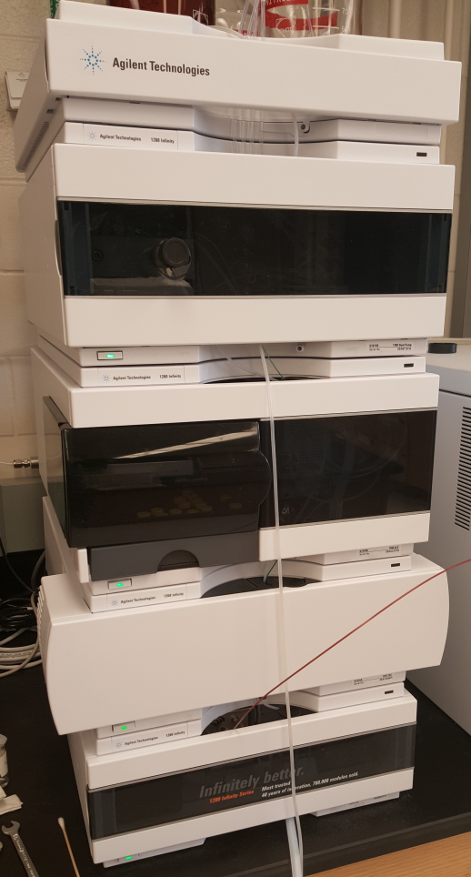
LCMS System
Agilent 1260 Infinity
This system delivers a pressure of 600 bars. It provides high sensitivity for diode array detector analyses because of its superior gradient accuracy. It also supports a wide range of LC and LCMS applications with a narrow and standard bore analytical column.
Quantity in the lab: 1
- Flow rate can reach 5 ml/min
- Configurable pump delay volume goes down to 120µL
- Contains a 100 well autosampler
- Autosampler ambient operating temperature: 0-55 ºC. Ambient non-operating temperature: 40-70 ºC.
- Minimum sample: 1 µL from 5 µL sample in 100 µL microvial; 1 µL from 10 µL from 300 µL microvial
- Room for two 30-cm columns
- Temperature range: 10ºC below ambient to 80ºC. Precision of ± 0.15ºC
- Temperature zones-2
- Heat up/cool down time: 5 minutes from ambient to 40ºC, 10 minutes from 40ºC-20ºC
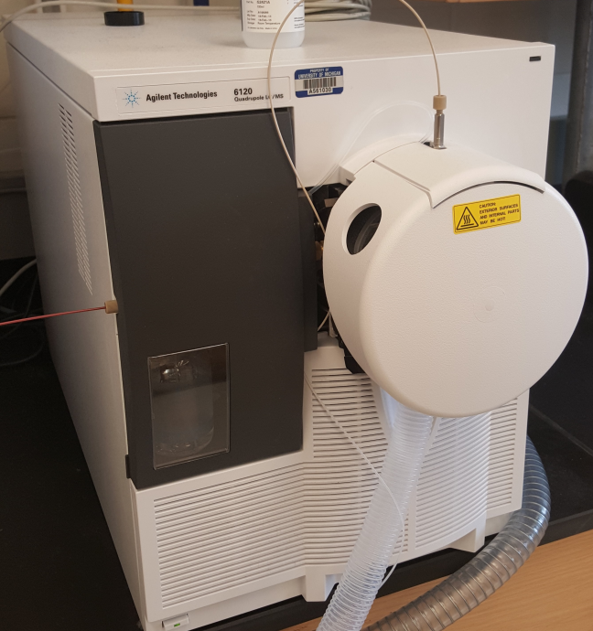
MS Model:6120
Contains an orthogonal flow sprayer with pneumatic nebulizer. High-capacity solvent drying system helps reduce chemical noise. Dielectric platinum-plated capillary enhances sensitivity, permits independent optimization of the spray chamber, and allows dynamic optimization of ion-source fragmentation. Also contains a air-cooled turbolmolecular pump to provide fast startup
- Mass range: m/z 10-1500 with an accuracy of ±0.13u
- Scan Speed: 2500 u/s.
- Flow rate- ESI up to 1.0 ml/min water without a flow splitter. APCI upto 1.5 ml/min without a flow splitter.
- Operating conditions: temperature range 15ºC-35ºC. Humidity less than 95%
Raman Spectrometer
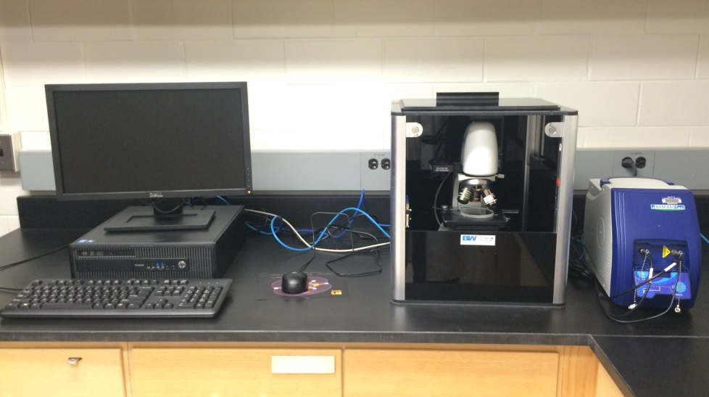
B&W Tek BAC151B
Quantity in Lab: 1
The unique dual laser wavelength port provides the flexibility for one system to be coupled with two different laser wavelengths. The integrated camera allows for precision Raman sampling through camera monitoring of the laser beam and imaging details.
- Ambient Temperature: 0-55ºC, humidity <85%
- Objective lens magnification ( size, working distance mm, laser beam spot size µm): (5X, 26.1, 420), (10X, 20.2, 210), (20X, 8.8, 105), (40X, 3.98, 52), (50X, 3.68, 42), (80X, 1.25, 26), (100X, 0.4, 21)
- Travel: 24 mm (Z), 75mm (X), 50 mm(Y)
- Active camera pizels: 1280x1024
Portable Raman System: i-Raman Plus
Using a high quantum efficiency CCD array detector with deeper cooling
and high dynamic range, this portable Raman spectrometer delivers an improved
signal to noise ratio for up to 30 minutes of integration time, making it possible to
measure weak Raman signals. The i-Raman Plus features the unique combination
of wide spectral coverage and high resolution with configurations measuring out to
4000cm⁻¹, enabling you to measure stretching bands around 3100cm⁻¹. The system’s
small footprint, lightweight design, and low power consumption provide research
grade Raman capabilities anywhere. The i-Raman Plus comes standard with a fiber
optic probe, and can be used with an XYZ positioning stage probe holder, a cuvette
holder, and our proprietary BWIQ multivariate analysis software..
Video Microscope: BAC151B
The BAC151B is a Video Microscope Raman Sampling System which includes an integrated camera and precision three dimensional axis adjustment controls. Precise Raman sampling and camera monitoring of the beam will show imaging details of the sampling spot. The image of the sample and sampling spots can be easily recorded and included in test reports together with spectral data by way of the BWSpec software.
The BAC151B comes with one 20x objective and is attachable to the 4-port turret system on the Microscope Sampling Stage. The Camera head of the BAC515B is compatible with any B&W Tek, Inc. Raman probe (BAC102).
Lab Grade Raman Probe: BAC102
The BAC102 is a fiber optic lab-grade Raman probe with hand trigger to be used with B&W Tek portable Raman systems. The innovative probe uses state-of-the-art package design and optimized optical lenses. For the 532nm and 785nm excitation wavelengths, the probe had a standard cut-on that starts at 175 cm⁻¹ and can be upgraded to 65 cm⁻¹ (E-grade filter upgrade). For the 1064nm laser excitation wavelength, the probe has a standard cut-on that starts at 250 cm⁻¹.

